PSA Pitch sheet
Ad Agency_________________________ Client:__________________________
PSA Campaign:_______________________
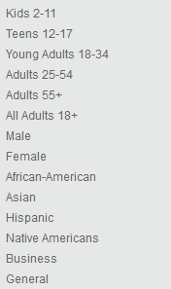
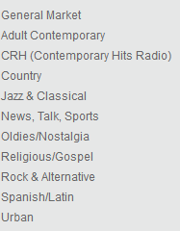
Target audience
Radio Station Format

Length: :30 or :60
Type: Straight __ Dramatized X Dialogue __ Comedy __ Punch __ Soft Sell __ Musical__ Jingle__
Unless approved all scripts will be dramatized, you may add additional elements as well.

Worksheet

What is the behavior you’re looking to change or affect?

Why doesn’t the audience already engage in this behavior?

What emotional appeal can you make? Belonging __ Power/Control__ Fun __ Safety __

What is a situation where this issue would come up in your target audience lives?
Where are they? (setting)

Who is there? (Talent)

What’s going on around them? (sfx / ambient noise)

What are they saying? (Dialogue)

What is the emotional feel of the situation? (music)

