1. Log on to computer
Make sure the audio for your computer is on or you have headphones plugged in
2. Go to I drive and locate audacity folder open the folder and double click on audacity-win-2.0.5
Just keep click next and stall until the program installs and launches
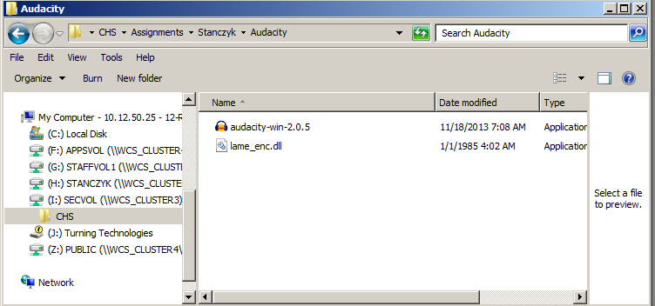
3. Go to File/ Import/ Audio and import the newscast you were in last week. (I drive)
If you did not do news you must import someone else’s news
4. Play back the audio file by pressing the space bar
Find the section where you are doing your news cast ( you can move around in the file by using your mouse and left clicking)
5. Click and drag on your audio section
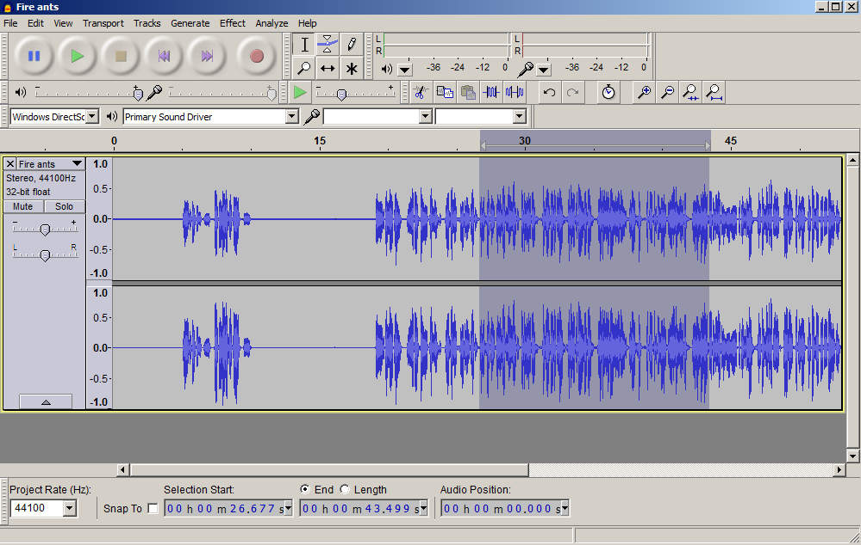

6. Export that selection your student drive
Give the file your full name as the file name
Save as type: should be MP3 Files
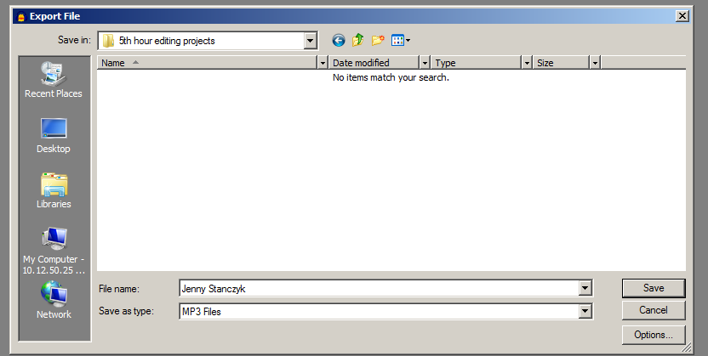
You should get this error message
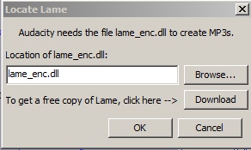
Click Browse and go to the I drive again, to the audacity folder and select Lame_enc.dll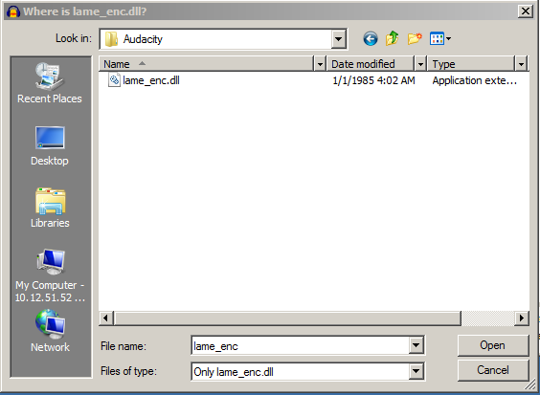
Once the encoder is installed continue to export your file.
Close the track you were working on.

Import the audio file you just saved

Split your newscast and add some space
Import and Sound effect
Place it under the blank space

Import a music file
Choose part of the music to place under your newcast. There should be no lyrics, just instrumental.
Adjust the volume for the music under Effects and Amplify

When it sound right, export the file to your student drive as an MP3

